SIMATS ENGINEERING (SAVEETHA SCHOOL OF ENGINEERING)
Department of Artificial Intelligence and Data Science
ASSESSMENT TOOL 1 – Analytical Problem Solving

Course Code: | DSA0304 | Course Title: | Natural Language Processing
CO Assessed: | CO2 – Manipulation | Assessment: | Assessment Tool 1 –  Analytical Problem Solving
Weightage: | 40% of CIA
CO1 Statement: | Analyse NLP models, regular expression patterns, finite state automata, morphological processing techniques and to interpret language processing. (BL-3)
Student Name: | G. Srilakshmi | Reg. No.: | 192425006
Section / Batch: | B.Tech – AIML (3rd year) | Date: | 13.07.2026

Code of Conduct
I G. Srilakshmi (192425006) certify that this submission is my original work and that I have adhered to the guidelines specified for this assessment. I understand that any violation of academic integrity rules will result in disciplinary action.
Signature of the Student: Srilakshmi

Instructions
- Develop a modular and efficient Python program that satisfies all the functional requirements specified in the problem statement.
- Demonstrate the correctness of the implementation using suitable test cases and justify the output obtained.
- Follow good programming practices, including meaningful variable names, proper code indentation, comments, and error handling wherever applicable.
- Duration: 30 minutes.

Section / Topic | Focus | Q Nos
Information Extraction | Regex-Based Information Extraction | 1
Pattern Matching | Regex Pattern Matching | 2
Regular Expression Patterns | Regex-Based Input Validation | 3

Annexure A – Analytical Problem Solving

Section 1: Morphological Analysis Pipeline
- Given the input words: “connected”, “connecting”, “connection”, design a morphological analysis pipeline for a document indexing system.
Apply rules to decompose each word into root and suffix components.
Differentiate between inflectional and derivational forms within the dataset.
Normalize all variants to a common base form for efficient retrieval.
Determine the parsed structure and normalized output for each word.
Write a Python program to implement the above morphological analysis pipeline. The program should accept the given input words, perform decomposition, classify each suffix as inflectional or derivational, normalize the words to their common base form, and display the parsed structure and normalized output in a tabular format.

Inflectional vs Derivational
connected
- Root: connect
- Suffix: -ed
- Indicates past tense.
- Does not create a new word.
- Inflectional Morphology
connecting
- Root: connect
- Suffix: -ing
- Indicates present participle/continuous form.
- Word meaning remains same.
- Inflectional Morphology
connection
- Root: connect
- Suffix: -ion
- Changes verb into noun.
- Creates a new lexical word.
- Derivational Morphology

CODE:
words = ["unhappy", "happiness", "happily"]
data = {
"unhappy": ("un", "happy", "-", "Derivational", "happy"),
"happiness": ("-", "happy", "ness", "Derivational", "happy"),
"happily": ("-", "happy", "ly", "Derivational", "happy")
}
print("{:<12}{:<10}{:<12}{:<10}{:<18}{:<15}".format(
"Word",
"Prefix",
"Base",
"Suffix",
"Type",
"Normalized"
))
print("-" * 80)
for word in words:
prefix, base, suffix, morph_type, normalized = data[word]
print("{:<12}{:<10}{:<12}{:<10}{:<18}{:<15}".format(
word,
prefix,
base,
suffix,
morph_type,
normalized
))

OUTPUT:

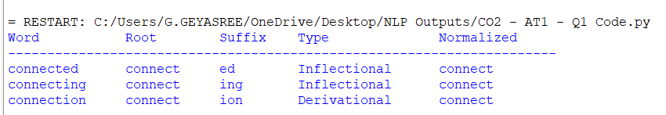

Section 2: Morphological Parsing Module
- Given the input words: “unhappy”, “happiness”, “happily”, design a morphological parsing module for sentiment analysis.

Identify prefixes, suffixes, and base forms using rule-based decomposition.
Ensure semantic consistency across derived word forms.
Classify each transformation as inflectional or derivational.
Produce the root and morphological breakdown for each word.
Write a Python program to implement the above morphological parsing module. The program should accept the given input words, identify the prefixes, suffixes, and base forms, classify each transformation as inflectional or derivational, and display the morphological breakdown and normalized root word in a tabular format.

Prefix, Suffix and Base Form Identification

1. unhappy
- Prefix: un-
- Base Form: happy
- Suffix: None
- Prefix un- changes the meaning from positive to negative.
- Transformation Type: Derivational

2. happiness
- Prefix: None
- Base Form: happy
- Suffix: -ness
- Converts the adjective happy into the noun happiness.
- Transformation Type: Derivational

3. happily
- Prefix: None
- Base Form: happy
- Suffix: -ly
- Converts the adjective happy into the adverb happily.
- Transformation Type: Derivational

CODE:
words = ["connected", "connecting", "connection"]
data = {
"connected": ("connect", "ed", "Inflectional", "connect"),
"connecting": ("connect", "ing", "Inflectional", "connect"),
"connection": ("connect", "ion", "Derivational", "connect")
}

print("{:<15}{:<12}{:<10}{:<18}{:<15}".format(
"Word", "Root", "Suffix", "Type", "Normalized"
))

print("-" * 70)

for word in words:
root, suffix, morph_type, normalized = data[word]
print("{:<15}{:<12}{:<10}{:<18}{:<15}".format(
word,
root,
suffix,
morph_type,
normalized
))

OUTPUT:

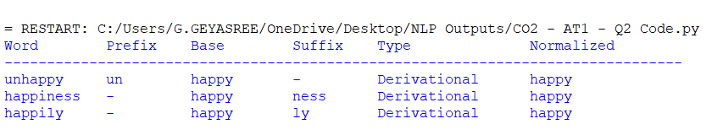
Section 3: Stemming-Based Preprocessing Module
3. Given the input words: “played”, “player”, “playing”, design a stemming-based preprocessing module for a search engine.
- Apply morphological rules to strip affixes and identify the base form.
- Handle both grammatical variations and word formation changes.
- Ensure consistent root extraction across all forms.
- Determine the stem and classification for each input word.
- Develop a Python program for a stemming-based preprocessing module used in a search engine. The program should process the input words "played", "player", "playing" by applying appropriate stemming rules to remove prefixes/suffixes where applicable, identify the stem of each word, distinguish between grammatical inflections and word-formation changes, and generate a structured output showing the original word, extracted stem, removed affix (if any), transformation type (inflectional/derivational), and the final normalized form suitable for indexing and information retrieval.

Explanation
1. played
- Stem: play
- Removed Affix: -ed
- Indicates past tense.
- No new word is formed.
- Inflectional Morphology

2. player
- Stem: play
- Removed Affix: -er
- Forms a noun from the verb play.
- Creates a new lexical word.
- Derivational Morphology
3. playing
- Stem: play
- Removed Affix: -ing
- Indicates present participle/continuous tense.
- Meaning remains the same.
- Inflectional Morphology

CODE:

words = ["played", "player", "playing"]

data = {
"played": ("play", "ed", "Inflectional", "play"),
"player": ("play", "er", "Derivational", "play"),
"playing": ("play", "ing", "Inflectional", "play")
}

print("{:<12}{:<12}{:<15}{:<18}{:<15}".format(
"Word",
"Stem",
"Removed Affix",
"Type",
"Normalized"
))

print("-" * 75)

for word in words:
stem, affix, trans_type, normalized = data[word]
print("{:<12}{:<12}{:<15}{:<18}{:<15}".format(
word,
stem,
affix,
trans_type,
normalized
))

OUTPUT:
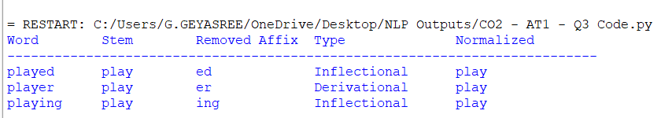
Section 4: Finite-State Morphological Parsing Module
Given the input words: “writes”, “writing”, “written”, design a finite-state morphological parsing module for a text processing system.
- Apply state transitions to represent suffix transformations and irregular forms in verb inflection.
- Differentiate between regular and irregular inflectional patterns within the dataset.
- Ensure consistent mapping of all forms to a common root representation.
- Determine the state transitions, morphological breakdown, and normalized output for each word.
- Develop a Python program that implements a finite-state morphological parser for the input words "writes", "writing", "written". The program should construct a finite-state transition model to process regular suffixes and irregular verb forms, identify the corresponding root word, classify each input as a regular or irregular inflection, trace the sequence of state transitions during parsing, and display the state transition path, morphological components, root form, and normalized representation for each input word in a well-formatted output.
State Transitions
1. writes
State Transition:
S0 → S1 → S2 → S4
Explanation:
- Root identified: write
- Suffix: -s
- Regular verb inflection
- Normalized Form: write

2. writing
State Transition:
S0 → S1 → S2 → S4
Explanation:
- Root identified: write
- Suffix: -ing
- Regular verb inflection
- Normalized Form: write

3. written
State Transition:
S0 → S1 → S3 → S4
Explanation:
- Root identified: write
- Irregular past participle
- Processed using irregular transition
- Normalized Form: write

CODE:

words = ["writes", "writing", "written"]

data = {
"writes": ("S0 → S1 → S2 → S4", "write", "Regular", "write"),
"writing": ("S0 → S1 → S2 → S4", "write", "Regular", "write"),
"written": ("S0 → S1 → S3 → S4", "write", "Irregular", "write")
}

print("{:<12}{:<22}{:<10}{:<12}{:<12}".format(
"Word",
"State Transition",
"Root",
"Pattern",
"Normalized"
))

print("-" * 75)

for word in words:
transition, root, pattern, normalized = data[word]
print("{:<12}{:<22}{:<10}{:<12}{:<12}".format(
word,
transition,
root,
pattern,
normalized
))

OUTPUT:
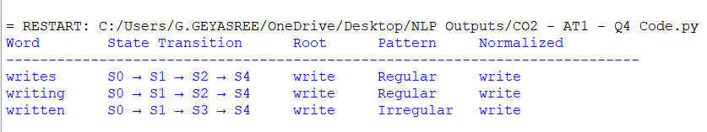
Section 5: Porter Stemmer-Based Preprocessing Module
5. Given the input words: “relational”, “relation”, “relate”, design a Porter Stemmer-based preprocessing module for document retrieval.
- Apply stemming rules step-by-step to remove derivational suffixes and obtain base forms.
- Handle variations in suffix patterns while preserving semantic consistency.
- Ensure uniform root extraction across all derived forms.
- Determine the stemming steps, intermediate forms, and final stem for each input word.
- Develop a Python program that implements the Porter Stemming algorithm for the input words "relational", "relation", "relate". The program should apply the Porter stemming rules sequentially to remove derivational suffixes, display the intermediate form obtained after each stemming step, handle different suffix patterns while preserving the word meaning, and generate the final stem for each word. The output should clearly present the original word, applied stemming rule(s), intermediate forms, and the final normalized stem in a structured format suitable for document retrieval applications.
Stemming Process
1. relational
- Original Word: relational
- Applied Rule: Remove -ational
- Intermediate Form: relate
- Applied Rule: Remove final -e
- Final Stem: relat
2. relation
- Original Word: relation
- Applied Rule: Remove -ion
- Intermediate Form: relate
- Applied Rule: Remove final -e
- Final Stem: relat
3. relate
- Original Word: relate
- Applied Rule: Remove final -e
- Intermediate Form: relat
- Final Stem: relat
CODE:

words = ["relational", "relation", "relate"]

data = {
"relational": ("Remove -ational, Remove -e", "relate", "relat"),
"relation": ("Remove -ion, Remove -e", "relate", "relat"),
"relate": ("Remove -e", "relat", "relat")
}

print("{:<15}{:<30}{:<20}{:<12}".format(
"Word",
"Applied Rule(s)",
"Intermediate",
"Final Stem"
))

print("-" * 85)

for word in words:
rules, intermediate, stem = data[word]
print("{:<15}{:<30}{:<20}{:<12}".format(
word,
rules,
intermediate,
stem
))

OUTPUT:
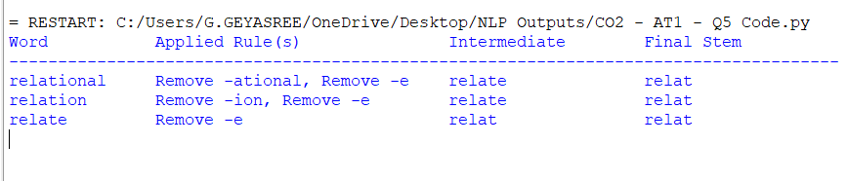

Rubrics for Calculation
Criteria | Weightage | Level 4 – Exemplary | Level 3 – Proficient | Level 2 – Developing | Level 1 – Beginning
Understanding of Problem Context | 20 | Clearly understands the problem and accurately identifies all requirements | Good understanding with minor gaps | Basic understanding; some requirements unclear | Poor understanding or misinterpretation of the problem
Application of Concepts | 30 | Accurately applies appropriate concepts to solve complex problems | Applies relevant concepts correctly with minor errors | Applies basic concepts with limited accuracy | Fails to apply appropriate concepts
Problem-Solving Approach | 20 | Logical, well-structured, and efficient approach | Mostly logical approach with minor gaps | Basic approach with some inconsistencies | Illogical or unclear approach
Accuracy of Solution | 20 | Completely correct solution with proper justification | Mostly correct with minor errors | Partially correct solution | Incorrect or incomplete solution
Clarity | 10 | Clear, well-organized, and properly explained solution | Understandable with minor clarity issues | Limited clarity and explanation | Poorly presented and difficult to understand

Q. No. / Criteria | Understanding of Problem Context | Application of Concepts | Problem-Solving Approach | Accuracy of Solution | Clarity | Sub. Total | Total %
1
2
3

Faculty In-charge | Course Coordinator | Program Director
Signature: _______________ | Signature: _______________ | Signature: _______________
Date: ___________________ | Date: ___________________ | Date: ___________________

